SQL Queries and Joins
NIKITA SANJAY MANE (41)

- Creating a Database

CREATE DATABASE DBMS41;

- Using the Database

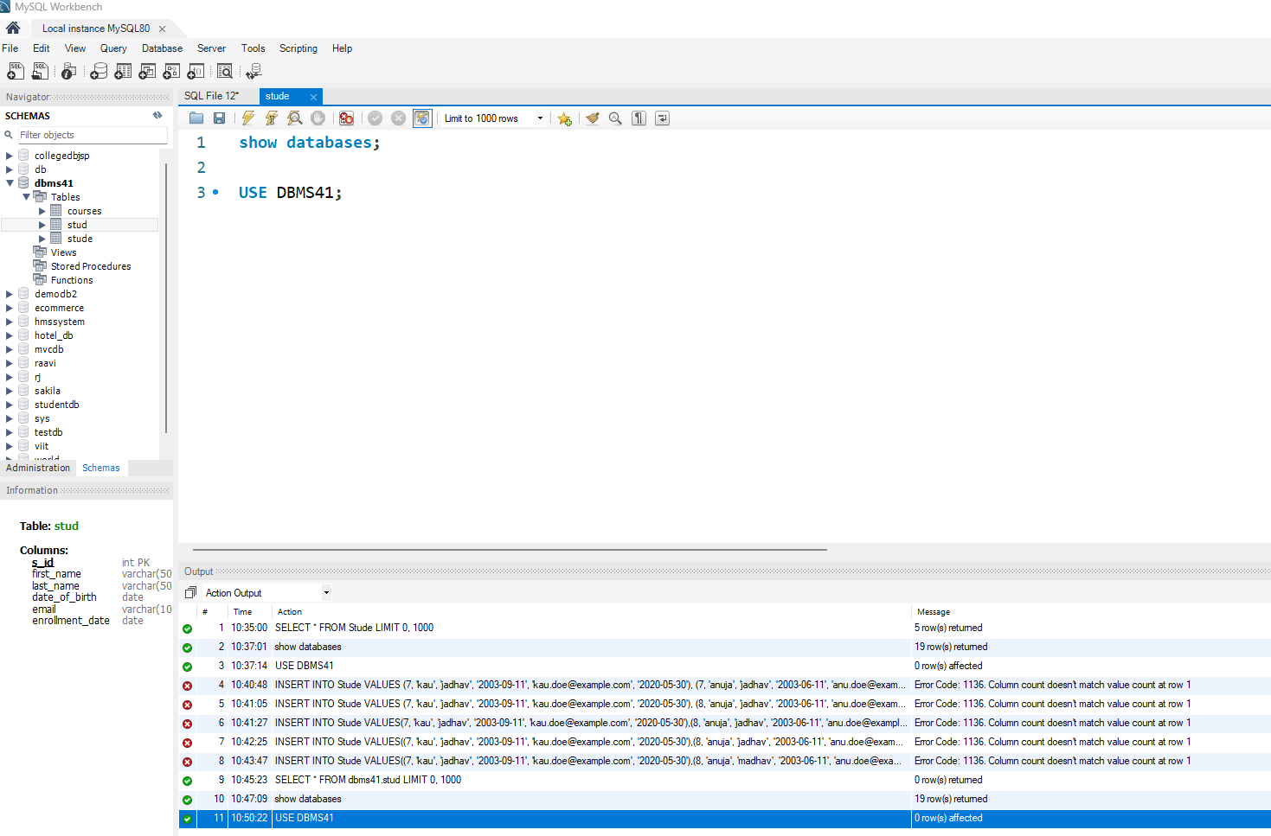

- Creating Tables

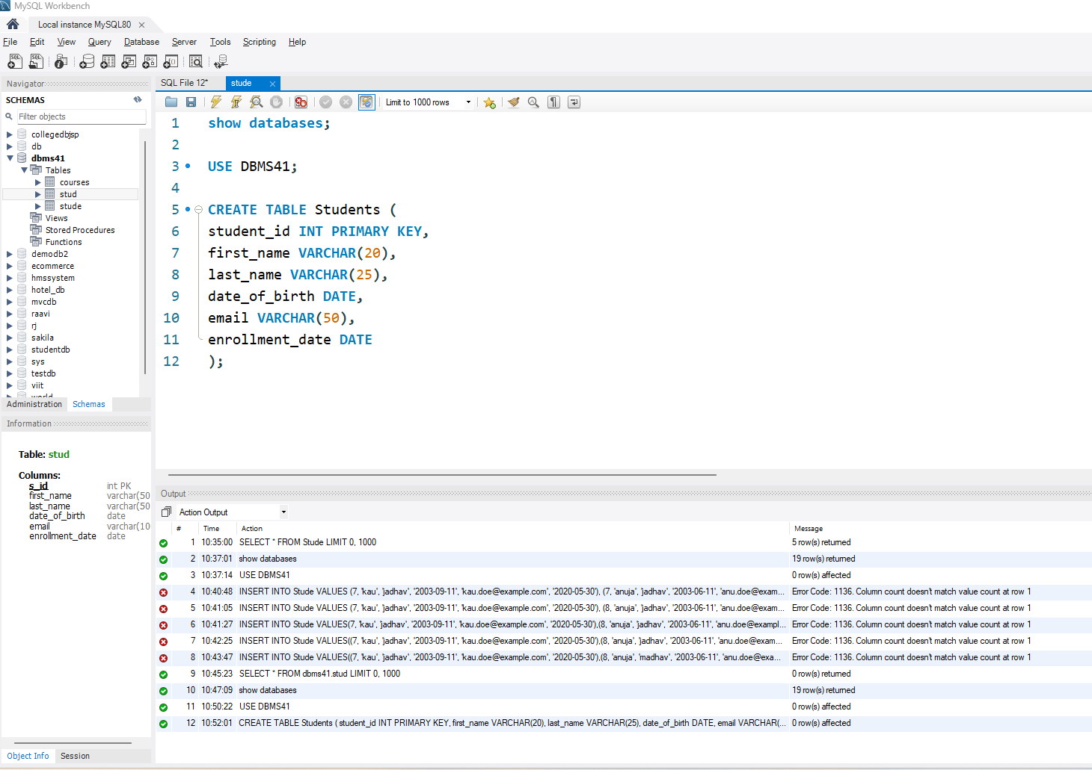

- Inserting Data into Tables

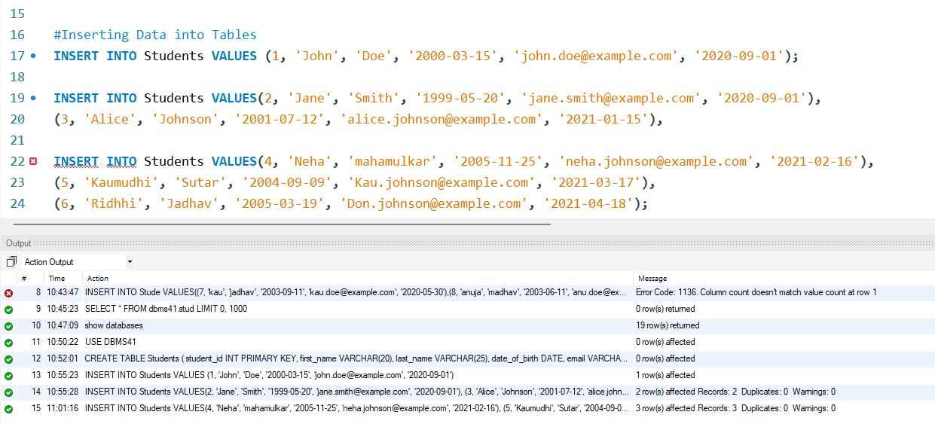

- Retrieving Data (SELECT)

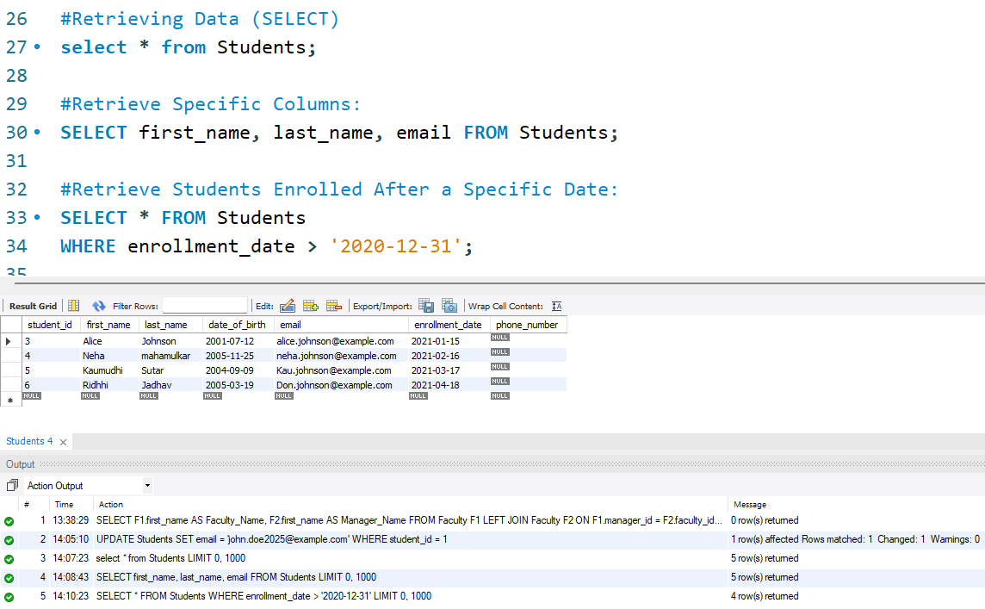

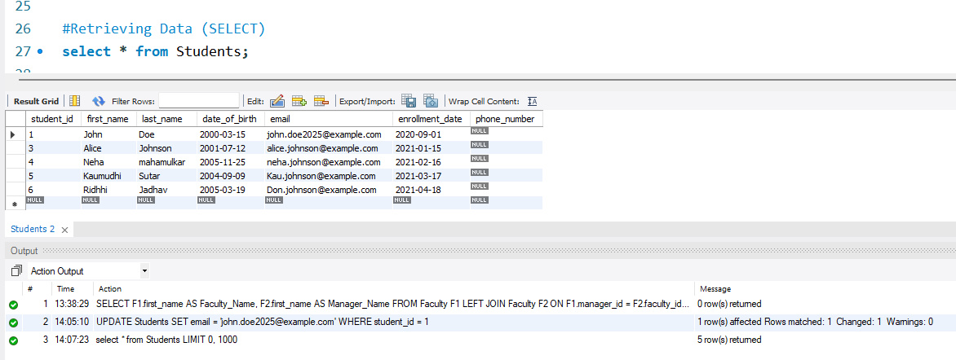

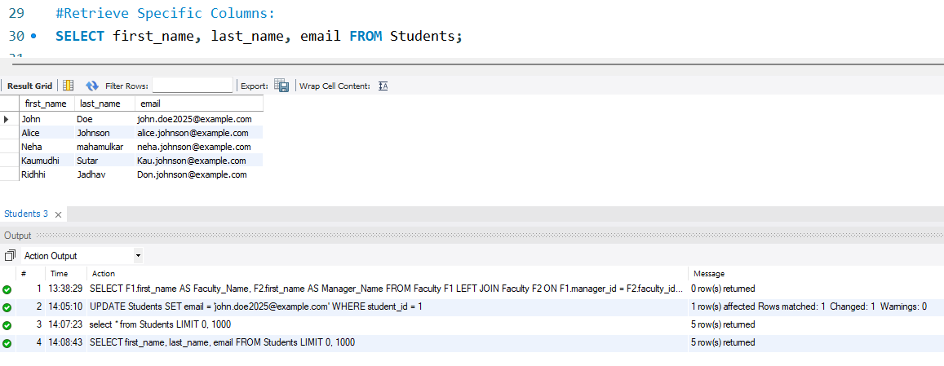

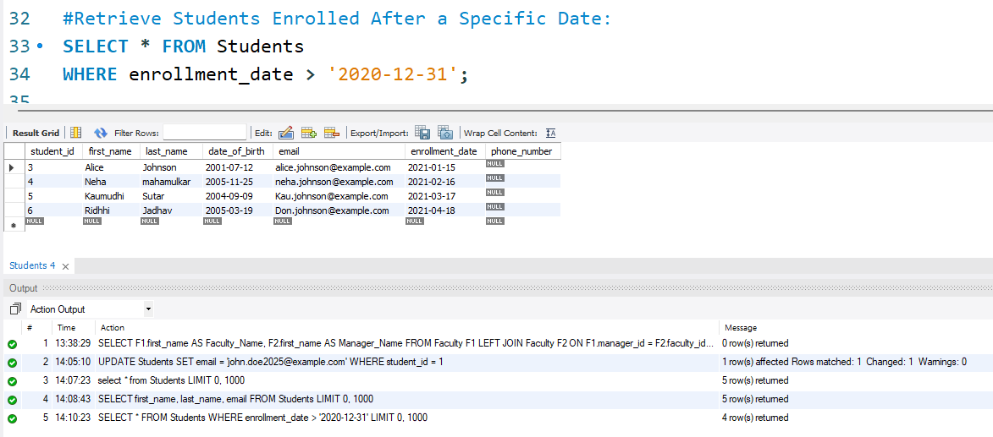

- Updating Data (UPDATE)

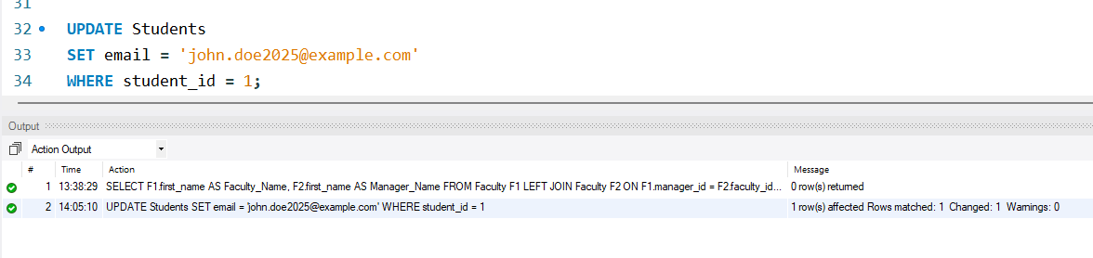

- Deleting Data (DELETE)

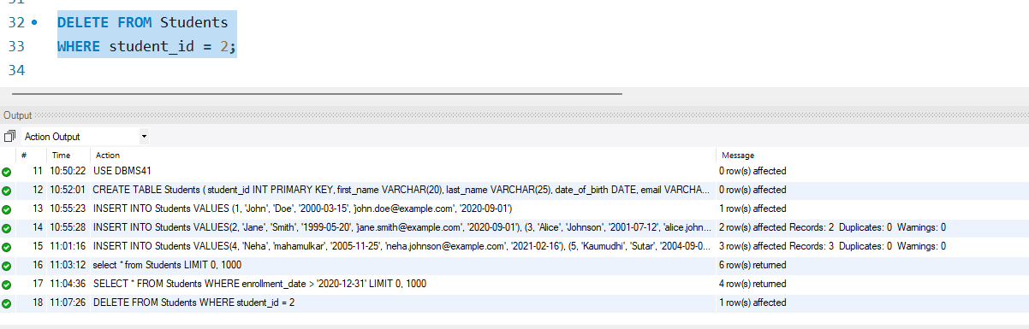

- Adding a Column to a Table

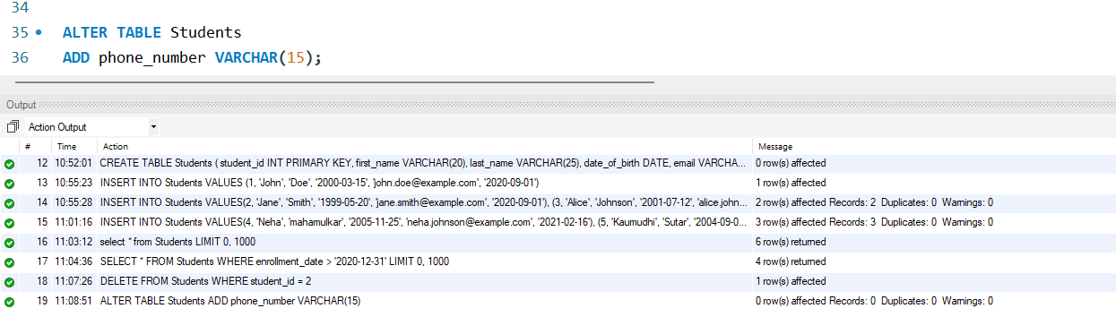

- Dropping a Table

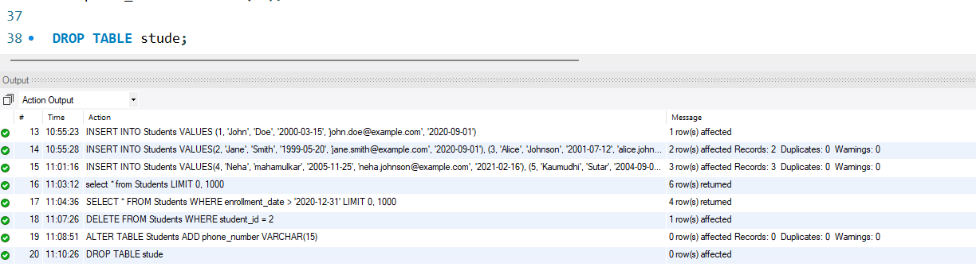
- Creating Relationships (Foreign Keys)

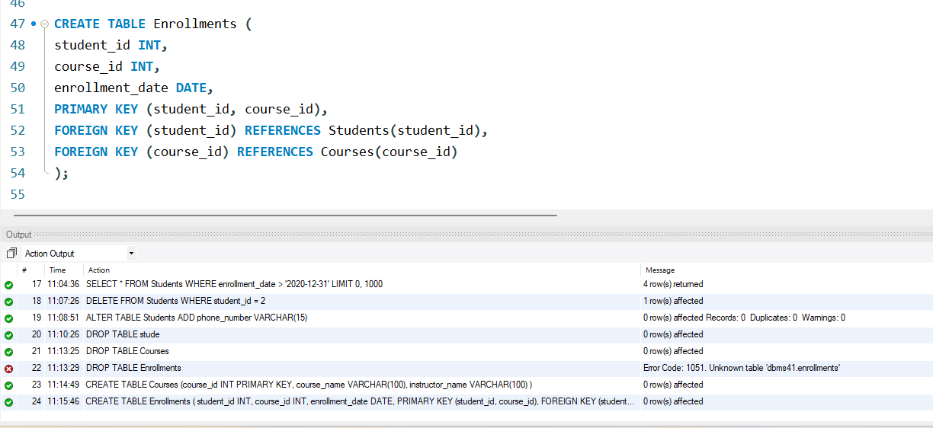

- Using JOINs (Combining Data from Multiple Tables)

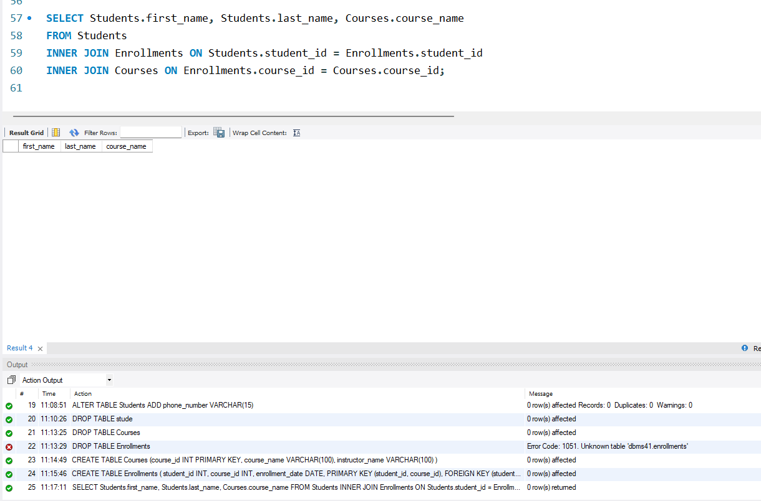

- INNER JOIN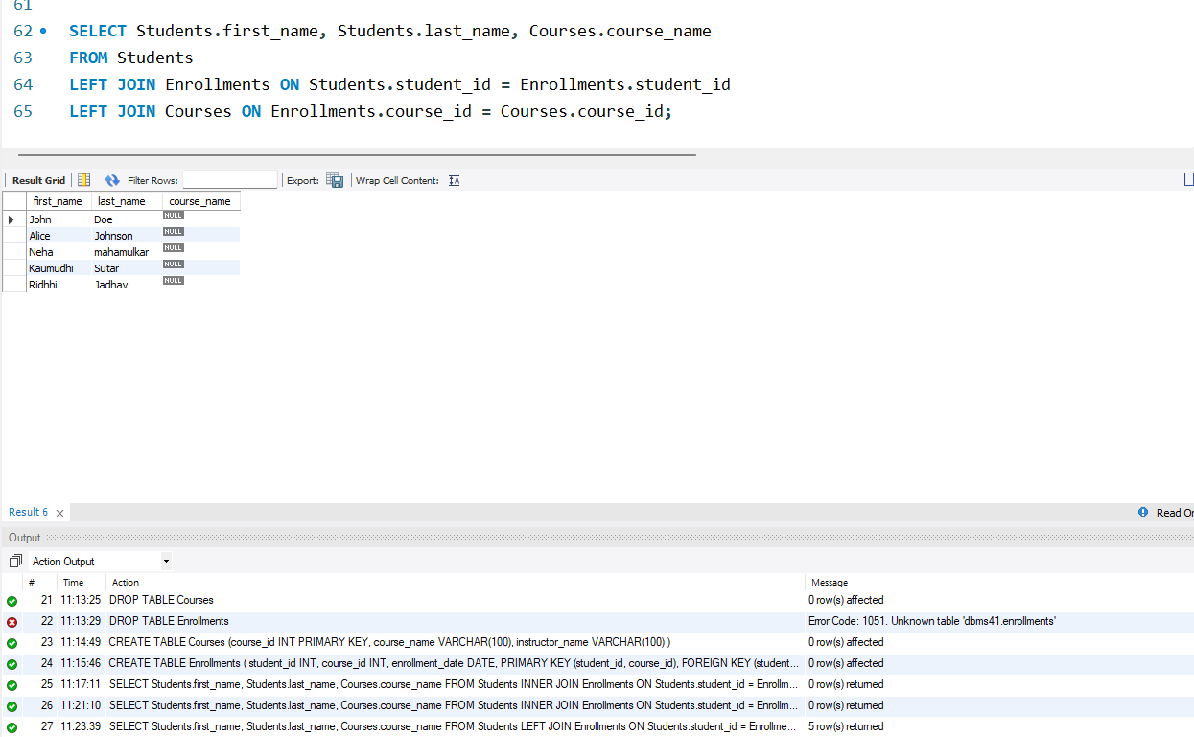
- LEFT JOIN (or LEFT OUTER JOIN)

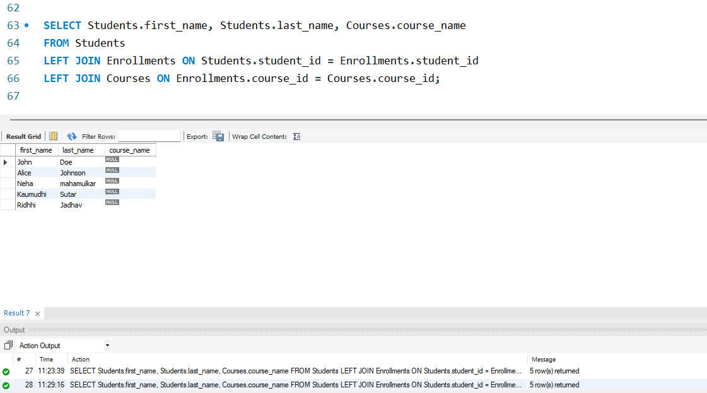

- RIGHT JOIN (or RIGHT OUTER JOIN)

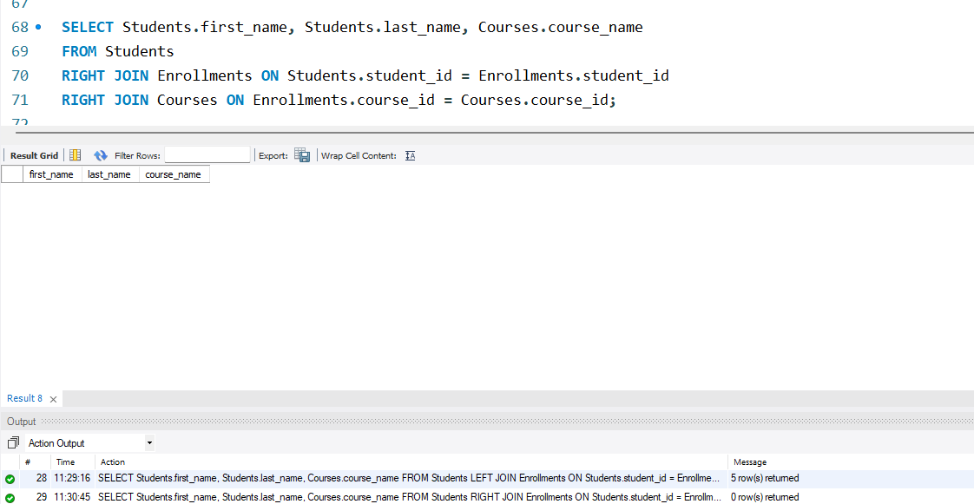

- FULL JOIN (or FULL OUTER JOIN)

SELECT Students.first_name, Students.last_name, Courses.course_name
FROM Students
FULL JOIN Enrollments ON Students.student_id = Enrollments.student_id
FULL JOIN Courses ON Enrollments.course_id = Courses.course_id;

- CROSS JOIN

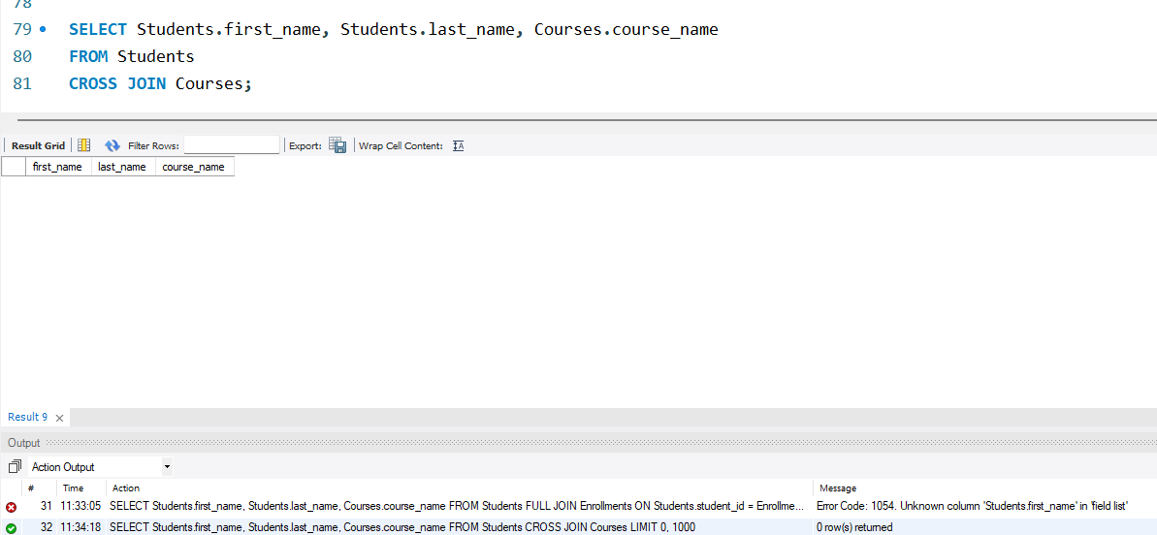

- SELF JOIN



